Chapter 9 MATLAB Graphic

% 9.1 BASIC 2-D GRAPHS

figure, plot(rand(1, 20));

a=rand(1, 20);

%-------------------------------

x = 0:pi/40:4*pi;

figure, plot(x, sin(x))

%-------------------------------

figure, plot([0 4], [1 3])

ezplot('log(x)')

x = 0:pi/40:2*pi;

figure, plot(sin(x), cos(x))

%-------------------------------

Sec. 9.1.1 Labels

gtext(’text’) : writes a string (’text’) in the graph window. Interactively by mouse to pointer the position of text in the figure.

grid on (or off) adds/removes grid lines to/from the current graph.

text(x, y, ’text’) writes text in the graphics window at the point specified

by x and y.

title(’text’) writes the text as a title on top of the graph.

xlabel(’horizontal’) labels the *x*-axis.

ylabel(’vertical’) labels the *y*-axis.

%-------------------------------

% 9.1.2 Multiple plots in a figure: on a same plot, & separate plots (subplot)

figure, plot(x,sin(x), x, cos(x), 'om--') % dashed with point

% to have independent y-axis labels on the left and the

% right,

x = 0:pi/40:4*pi;

figure(4), plotyy(x,sin(x), x, 10*cos(x))

%-------------------------------

[x, y] = meshgrid(-3:0.3:3);

z = x .* exp(-x.^2 - y.^2);

subplot(2,2,1)

mesh(z),title('subplot(2,2,1)')

subplot(2,2,2)

mesh(z)

% after mesh, use different view for the subplot

view(-37.5,70),title('subplot(2,2,2)')

subplot(2,2,3)

mesh(z)

view(37.5,-10),title('subplot(2,2,3)')

subplot(2,2,4)

mesh(z)

view(0,0),title('subplot(2,2,4)')

% Sec. 9.1.3 Line styles, markets, and color

x = 0:pi/40:4*pi;

figure, plot(x, sin(x), '--') % dashed line

figure, plot(x, sin(x), 'o') % point type

figure, plot(x,sin(x), x, cos(x), 'om--') % dashed with point

% Various line types, plot symbols and colors may be obtained with

% plot(X,Y,S) where S is a character string made from one element

% from any or all the following 3 columns:

%

% b blue . point - solid

% g green o circle : dotted

% r red x x-mark -. dashdot

% c cyan + plus -- dashed

% m magenta * star (none) no line

% y yellow s square

% k black d diamond

% w white v triangle (down)

% ^ triangle (up)

% < triangle (left)

% > triangle (right)

% p pentagram

% h hexagram

%

% For example, plot(X,Y,'c+:') plots a cyan dotted line with a plus

% at each data point; plot(X,Y,'bd') plots blue diamond at each data

% point but does not draw any line

% Example

% x = -pi:pi/10:pi;

% y = tan(sin(x)) - sin(tan(x));

% plot(x,y,'--rs','LineWidth',2,...

% 'MarkerEdgeColor','k',...

% 'MarkerFaceColor','g',...

% 'MarkerSize',10)

%------Sec---9.1.4 ----------------------

% axis( [xmin, xmax, ymin, ymax] )

clear all;

x = 0:pi/40:4*pi;

figure, plot(x, sin(x), '--') % dashed line

axis( [0 pi*4 -1 1] )

% graphical input : allows you to select an unlimited number of points

% from the current graph using a mouse or arrow keys. press Enter terminate to terminate

clc;clear all;

[x,y]=ginput;

[x,y]=ginput(n);

% 9.1.8 Logarithmic plots

x = 0:0.01:4;

figure, semilogy(x, exp(x)), grid

% See also semilogx, loglog.

%-------------------------------

% 9.1.9 Polar plots

x = 0:pi/40:2*pi;

figure, polar(x, sin(2*x)),grid

%-------------------------------

% 9.1.10 Plotting rapidly changing mathematical functions: fplot

x = 0.01:0.001:0.1;

figure, plot(x, sin(1./x))

%-------------------------------

% fplot evaluates it more frequently over regions where it changes more rapidly

figure, fplot(@(x)sin(1./x), [0.01 0.1]) % no, 1./x not needed!

% 9.1.11 The property editor

**Edit** -> **Figure Properties** from the figure window. Editor figure.

Check table 9.1

%==============================================% Exercise: Example

x = -pi:pi/10:pi;

y = tan(sin(x)) - sin(tan(x));

plot(x,y,'--rs','LineWidth',2,...

'MarkerEdgeColor','k',...

'MarkerFaceColor','g',...

'MarkerSize',10)

text(x, y,'text');

title('text') % writes the text as a title on top of the graph.

xlabel('horizontal') % labels the x-axis.

ylabel('vertical') % labels the y-axis.

% Please use this as an example to change the figure properties :

% Like line and label fonts, etc. one can also use figure editor in the figure window.

% Sec 9.2 3-D plot

% 9.2.1 plot3

clear all; close all;

figure, plot3(rand(1,10), rand(1,10), rand(1,10))

%---------------------------------------------

t = 0:pi/50:10*pi;

figure, plot3(exp(-0.02*t).*sin(t), exp(-0.02*t).*cos(t),t), ...

xlabel('x-axis'), ylabel('y-axis'), zlabel('z-axis')

%---------------------------------------------

% 9.2.2 Animated 3-D plots with comet3

t = 0:pi/50:10*pi;

% it draws with a moving ¡¥comet head¡¦.

figure, comet3(exp(-0.02*t).*sin(t), exp(-0.02*t).*cos(t),t), ...

xlabel('x-axis'), ylabel('y-axis'), zlabel('z-axis')

% 9.2.3 Mesh surfaces

% The first step is to set up the grid in the x-y plane over which the surface is to be plotted.

[x y] = meshgrid(0:5,0:0.5:5); % generate a meshgrid

z = x.^2 - y.^2;

figure;mesh(x,y,z)

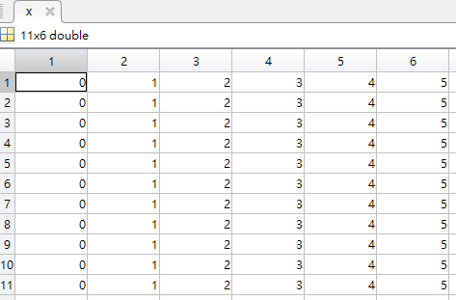 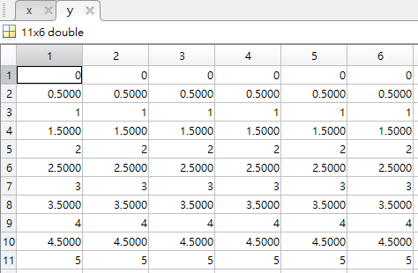

dis=sqrt(x.^2 + y.^2);

mesh(x,y,dis)

axis([0 5 0 5 0 10])

% generate the surface points:

[x, y] = meshgrid(-3:0.3:3);

z = x.^2 - y.^2;

% plot the surface points:

figure, mesh(z);

[x, y] = meshgrid(-3:0.3:3);

z = x .* exp(-x.^2 - y.^2);

% mesh(x,y,Z) and mesh(x,y,Z,C), with two vector arguments replacing

% the first two matrix arguments, must have length(x) = n and

% length(y) = m where [m,n] = size(Z). In this case, the vertices

% of the mesh lines are the triples (x(j), y(i), Z(i,j)).

% Note that x corresponds to the columns of Z and y corresponds to

% the rows.

figure(2);mesh(x,y,z)

figure(4);contour(z)



% In this case, the vertices of the surface facets;

% are the triples (x(j),y(i),Z(i,j)). Note that x corresponds to the

% columns of Z and y corresponds to the rows of Z. For a complete

% discussion of parametric surfaces, using the tilted surface (planar % surface) for the representation: see the SURF function.

figure(3);surface(x,y,z)

figure(5);surfc(x,y,z)

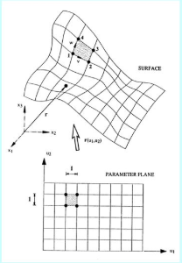 

%-------------------------------

% This drawing is another example of a mesh surface.

[x y ] = meshgrid(-8 : 0.5 : 8);

r = sqrt(x.^2 + y.^2) + eps;

z = sin(r) ./ r;

figure, mesh(z);

figure, mesh(x,y,z);

figure, surface(z); % You can change the viewpoint in the figure window

figure, surface(x,y,z)

**Exercises**

1. Draw the surface shown in Figure 9.7 with a finer mesh (of 0.25 units in each direction), using

[x y] = meshgrid(0:0.25:5);

(the number of mesh points in each direction is 21).

2. The initial heat distribution over a steel plate is given by the function

*u(x, y)* = 

Plot the surface *u* over the grid defined by

−2*.*1 ≤ *x* ≤ 2*.*1*,* −6 ≤ *y* ≤ 6*,*

where the grid width is 0.15 in both directions. You should get the plot shown in

Figure 9.8.

%-------------------------------

% 9.2.4 Contour plots

[x y] = meshgrid(-2.1:0.15:2.1,-6:0.15:6); % x-y-grids different

z = 80 * y.^2 .* exp(-x.^2 - 0.3*y.^2);

figure(9), contour(z)

figure(10);meshc(z)

figure, contour(z, 20)

figure, contour3(z)

%-------------------------------

[x y] = meshgrid(-2:.2:2);

z = x .* exp(-x.^2 - y.^2);

figure, meshc(z)

figure, surfc(z)

%-------------------------------

% 9.2.5 Cropping a surface with NaNs

%  *If a matrix for a surface plot contains NaNs, these elements are not plotted*. This

% enables you to cut away (crop) parts of a surface.

[x y] = meshgrid(-2:.2:2, -2:.2:2);

z = x .* exp(-x.^2 - y.^2);

c = z; % preserve the original surface

figure;mesh(c)

c(1:11,1:21) = NaN*c(1:11,1:21);

figure;mesh(c), xlabel('x-axis'), ylabel('y-axis')

%-------------------------------

% 9.2.6 Visualizing vector fields

[x y] = meshgrid(-2:.2:2, -2:.2:2);

V = x.^2 + y;

% [FX,FY] = gradient(F) returns the numerical gradient of the

% matrix F. FX corresponds to dF/dx, the differences in x (horizontal)

% direction. FY corresponds to dF/dy, the differences in y (vertical)

% direction. The spacing between points in each direction is assumed to

% be one.

[dx,dy]=gradient(V,0.2,0.2);

% dx = 2*x;

% dy=ones(size(dx));

% dy = dx; % dy same size as dx

% dy(:,:) = 1; % now dy is same size as dx but all 1’s

figure;

contour(x, y, V), hold on

quiver(x, y, dx, dy), hold off

%-------------------------------

% you can use the gradient function to estimate the derivatives:

[x y] = meshgrid(-2:.2:2, -2:.2:2);

V = x.^2 + y;

[dx dy] = gradient(V, 0.2, 0.2);

contour(x, y, V), hold on

quiver(x, y, dx, dy), hold off

%-------------------------------

% 9.2.7 Visualization of matrices: use mesh to check the values in the

% matrix.

a = zeros(30,30);

a(:,15) = 0.2*ones(30,1);

a(7,:) = 0.1*ones(1,30);

a(15,15) = 1;

mesh(a)

%-------------------------------

% 9.2.8 Rotation of 3-D graphs

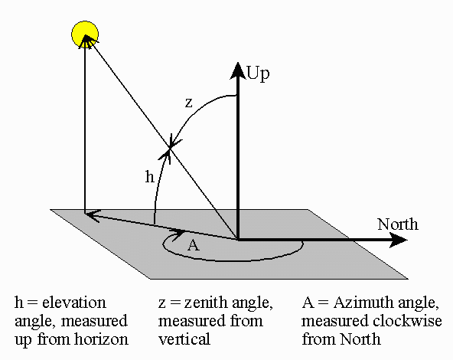clear all;close all;

figure;

a = zeros(30,30);

a(:,15) = 0.2*ones(30,1);

a(7,:) = 0.1*ones(1,30);

a(15,15) = 1;

el = 30;

% rotate around z-axis

for az = -37.5:30:-37.5+360

mesh(a), view(az, el)

pause(0.5)

end

% The program therefore rotates you in a counter-clockwise direction about the

*% z*-axis in 15◦ steps starting at the default position.

figure; mesh(a);

figure;

az=30;

for el = -37.5:30:-37.5+360

mesh(a), view(az, el)

pause(1.0)

end

The second argument of view is the vertical elevation el (in degrees). This is

the angle a line from the viewpoint makes with the *x*-*y* plane. A value of 90◦

for el means you are directly overhead. Positive values of the elevation mean

you are above the *x*-*y* plane; negative values mean you are below it.

1. Use keyword “commons graphic function” in search document in MATLAB to see the general graphic function for the matlab
2. 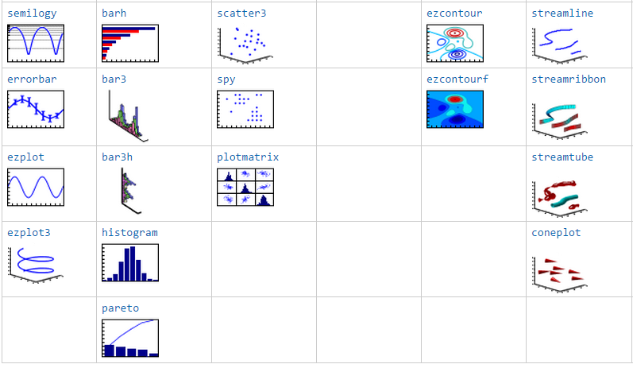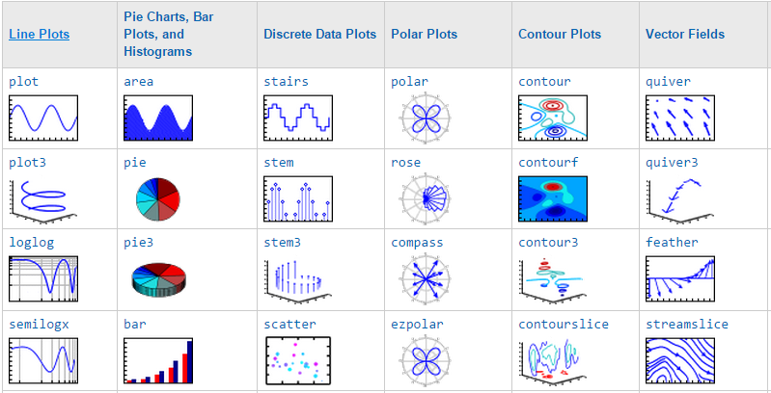

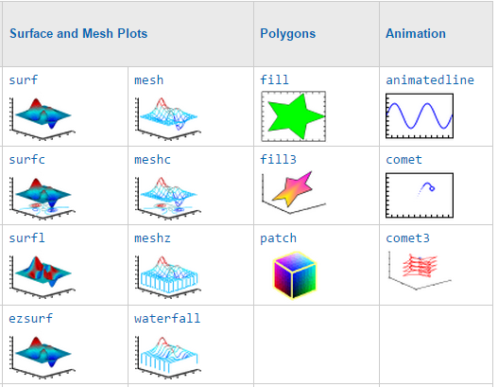

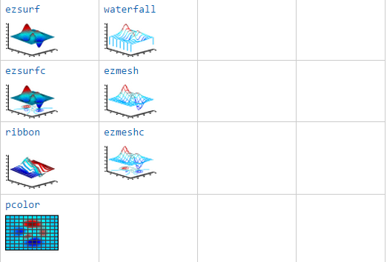

1. Two ways to edit the figure properties:
   1. Edit plot see Sec. 9.4.
   2. Through graphic handle see sec.9.3.

Sec. 9.3 handle graphics

* online documentation **MATLAB Help: Graphics**.

**Graphic object: Graphs Are Composed of Specific Objects**

When you create a graph, for example by calling the plot function, MATLAB automatically performs a number of steps to produce the graph.

(1) creating objects,

(2) setting the properties of these objects to appropriate values for your specific graph.

For example

x = 0:pi/20:2*pi;

hsin = plot(x,sin(x));

hsin.Color='red';

hsin.LineWidth=4;

% Chart Line properties can be check by the help MATLAB documentation

hold on

hx=xlabel('x-axis')

hcos = plot(x,cos(x))

hold off

 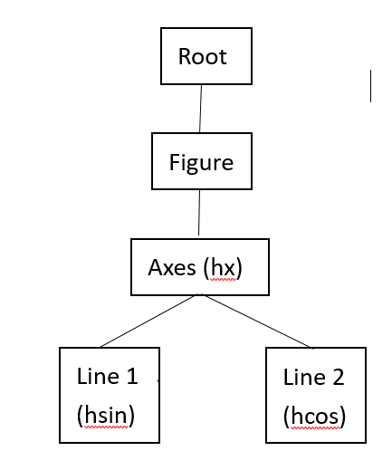

The objects are arranged in a parent-child inheritance structure as shown in Figure 9.13. For example, Line and Text objects are children of Axes objects.

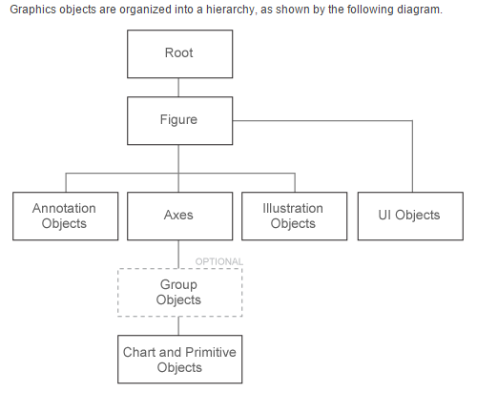

Fig. 9.1 Hierarchical structure of the graphic objects

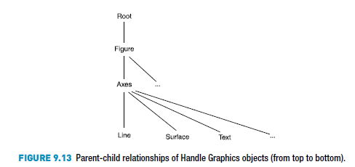

Whenever MATLAB creates a graphics objects it automatically creates a handle to that object.

* MATLAB creates a figure object, two chartline object

1. You can get the handle of the object using a function.
2. Use the handle to change the object properties
   * How to change the object properties through the object handle?
   * online documentation MATLAB Help: Graphics object properties. -> Chart Line Properties
     1. use get(object handle) to find all of the object properties, as in p.216.
     2. Change the object properties: use set (or just object handle.properties name= ---)

Example:

x = 0:pi/20:2*pi;

hsin = plot(x,sin(x));

get(hsin,’ty’) % what kind of object for the handle

get(hsin)

hsin.Color='red';

hsin.LineWidth=4;

% Chart Line properties: the help MATLAB documentation

There are three functions that return the handle of particular graphics objects:

gcf gets the handle of the current figure, e.g., hf = gcf;

gca gets the handle of the current axes.

gco gets the handle of the current graphics object. In the Figure Edit Model, you first select an object by mouse interactively, then use the common h=gco, MATLAB will return an handle of the selected object.

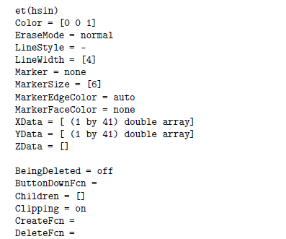

* Use the handle to change or manipulate your graphics object.

In command window: >> get(hsin)

You will get all properties of this object. In p. 216

Then use the command:

hsin.Color='red';

hsin.LineWidth=4;

Also, you can use the old version with the set function:

set(*handle, ‘PropertyName’, PropertyValue*)



 Figure 9.14

* You can find the object through the properties of the objects. In the original version of the plots in Figure 9.14 the decaying plot can be identified by its marker property:

hdecay = findobj(’marker’, ’o’ ) % return the handle of the ‘decaying line’.

% 9.3.3 A vector of handles

One figure , two Chart Line.

x = 0:pi/20:4*pi;

plot(x,sin(x))

hold on

plot(x,exp(-0.1*x).*sin(x),'o')

hold off

% get the object handles of the Childs of the figure

hkids=get(gca,'child');

set(hkids(1),'marker','*') % set the line property of the line 1

set(hkids(2),'LineWidth',4) % set the property of line 2

%%

hkids(1).Marker='o';

hkids(2).LineWidth=2;hkids(2).Color='blue';

% Sec. 9.4 Editing plots

Select **Tools** -> **Edit Plot** in the figure window.

In PLOT EDIT MODE to

1. Change the line type of the figure.
2. Change the label, Axis.
3. Insert title, legend & textbox & line arrows

% 9.4 To experiment with the Property Editor it will be useful

% to have multiple plots in a figure:

x = 0:pi/20:2*pi;

figure, plot(x,sin(x), x, cos(x), 'om--') % dashed with point

hsin = plot(x,sin(x))

hold on

hcos = plot(x,cos(x))

hold off

% check text p. 220 to insert Legend, textbox, label

% of the graphic insert a line and arrow

Use insert here

Textbox &

line arrow

legend

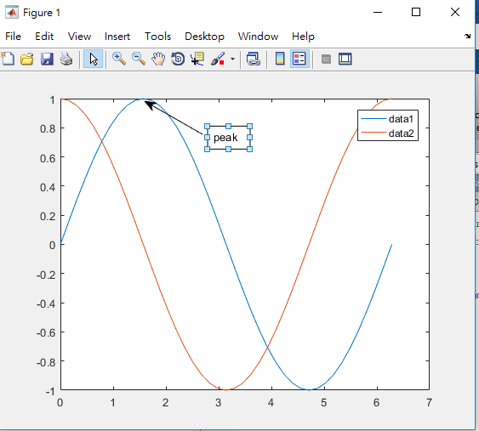

Sec. 9.4.2: In PLOT EDIT MODE, Double click on an object, you are starting

the PROPERTIES EDITOR

you can change the properties for the objects in this figure: figure line, Axes, text, etc.

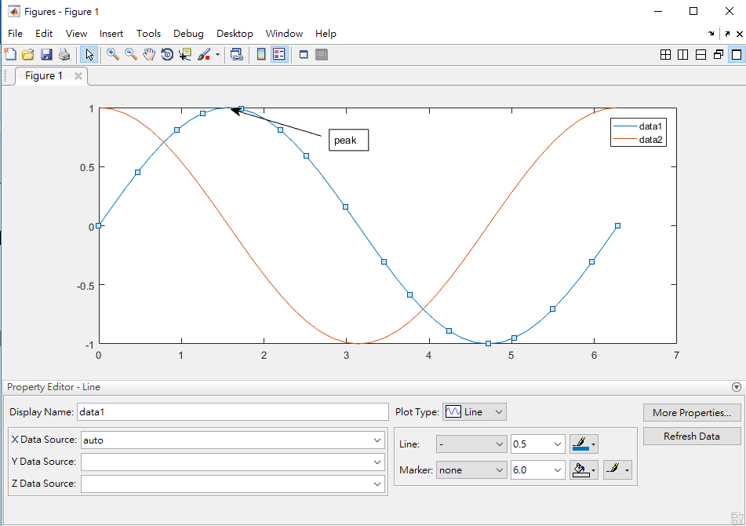

% 9.5 ANIMATION

% It generates 16 frames from the Fast Fourier Transforms of complex matrices:

clear all;

close all;

for k = 1:16

plot(fft(eye(k+16)))

axis equal

drawnow % draw inside the loop this frame now

M(k) = getframe;

end

% Movies outside the loop also call playback

figure(11), movie(M, 5)

% movie(M,n) plays the movie n times.

% movie(M,n,fps) plays the movie at fps frames per second.

% The default is 12 frames per second.

% try to use this command to change the rate of the movie

figure(22)

Z = peaks;

surf(Z)

axis tight manual

ax = gca; % get handle of the current axes

% To fix the figure properties by just change only the children

% check the fig. 9.13 in p. 215 that surface is the children of the Axes

ax.NextPlot = 'replaceChildren';

loops = 40;

% Initialization of the Movies through structure

% F(loops) = struct('cdata',[],'colormap',[]);

for j = 1:loops

X = sin(j*pi/10)*Z; % redefine the surface data

surf(X,Z)

drawnow % draw this frame now

% % get a frame of image with the definition by loop

F(j) = getframe; % to generate a sequence of frames (Movies)

End

%% F store a sequence of frames from the for loop.

figure(33), movie(F, 3)

%-------------------------------

% 9.5.1 Animation with Handle Graphics

% animated sine graph

x = 0;

y = 0;

dx = pi/40;

figure;

p = animatedline;

p.LineStyle='none';

p.Marker= 'o';

% since the 'EraseMode','none' function havs been remove in the new-version, one replace it by animatedline

axis([0 20*pi -2 2])

for x = dx:dx:20*pi;

x = x + dx;

y = sin(x);

% change the properties of the plot object

% one can use the command >> get(p) to find all properties

% of the plot

% set(p, 'XData', x, 'YData', y)

% p.XData=x;p.YData=y;

p.Color=rand(1,3);

addpoints(p,x,y);

pause(0.5);

drawnow

end

% another example

figure;

h = animatedline;

axis([0 4*pi -1 1])

x = linspace(0,4*pi,100);

h.LineStyle='none';

h.Marker= 'o';

for k = 1:length(x)

y = sin(x(k));

addpoints(h,x(k),y);

drawnow

end

%-------------------------------

% The Lorenz strange attractor.

figure;

A = [ -8/3 0 0; 0 -10 10; 0 28 -1 ];

y = [35 -10 -7]';

h = 0.01;

p = plot3(y(1), y(2), y(3), 'o', ...

'erasemode','none','markersize', 2);

axis([0 50 -25 25 -25 25])

hold on

i = 1;

while 1

A(1,3) = y(2);

A(3,1) = -y(2);

ydot = A*y;

y = y + h*ydot;

% Change colour occasionally

if rem(i,500) == 0

set(p, 'color', [rand, rand, rand])

end

% Change co-ordinates

p.XData=y(1);p.YData=y(2);p.ZData=y(3);

drawnow

i=i+1;

end

% since the function : 'erasemode','none', has been removed

% so, we use comet3 to plot this figure

% The Lorenz strange attractor.

clear all;close all;

figure;

A = [ -8/3 0 0; 0 -10 10; 0 28 -1 ];

y (1,:)= [35 -10 -7]';

h = 0.01;

i = 1;

for t=1:1000

A(1,3) = y(t,2);

A(3,1) = -y(t,2);

ydot = A*y(t,:)';

y(t+1,:) = y(t,:) + (h.*ydot)';

end

comet3(y(:,1),y(:,2),y(:,3))

% 9.6 color etc.

Color map representation

The values in the indexed image represent the address of the color in the colormap.

(indexed image)

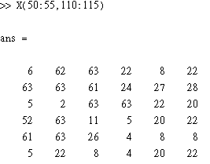

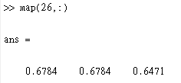

Colormap(map)

(color image)



Help document for the colormap

%% Sec. 9.6

% indexed image of a color image

load earth

imshow(X,[])

figure(2)

imshow(X,map)

imrect

% application to the different color plot

figure

surf(peaks)

colormap winter % Build-in map with 64 color

% Self-defined color

% Color RGB Triplet

% yellow [1,1,0]% magenta [1,0,1]% cyan [0,1,1]

% red [1,0,0]% green [0,1,0]% blue [0,0,1]% white [1,1,1]

% black [0,0,0]

close all;clear all;

z=peaks

cmap = [0.2, 0.1, 0.5

0.1, 0.5, 0.8

0.2, 0.7, 0.6

0.8, 0.7, 0.3

0.9, 1, 0];

% application to the different color plot

figure(1); surface(z);view(-35,35);colormap default

figure(2); surface(z);view(-35,35);colormap autumn

% self defined color & indicate the color bar

figure(3); surface(z);view(-35,35);colormap(cmap);colorbar

z=peaks(25);

c(:,:,1)=rand(25); % 25*25 random values 0~1

c(:,:,2)=rand(25);

c(:,:,3)=rand(25);

surf(z,c);

% The three pages of c specify the values of RGB,

%% 9.7 lighting and camera

% camlight : Create or move a light with respect to the camera position

% lightangle : Create or position a light in spherical coordinates

% light : Create a light object

figure;

surf(peaks)

axis vis3d

h = light; % return a light handle

get(h)

% h = camlight('left');

for az = -50:10:50

lightangle(h,az,30) % camera fixed & lighting changed with az angle

pause(.4)

end

% camera Lighting form the right

% Create or move light object in camera coordinates

figure(2);

surf(peaks)

axis vis3d

h = light; % return a light handle

for i=1:4

camlight('right') % add the light for the graphic

pause(.5)

end

% camera Lighting form the left

figure(2);

surf(peaks)

axis vis3d

for i=1:4

camlight left

pause(.5)

end

figure(3);

surf(peaks)

axis vis3d

h = camlight('left'); % return a camera lighting handle

for i = 1:20;

camorbit(10,0) % rotate the camera along z=axis by 10 degree

camlight(h,'left') % lighting change with of the cmaera position

pause(.1)

end

% Sec 9.8

Copy option & copy figure

File save & Export setup & print

